Contents
1. Project Overview 1
Project Title 1
2. Objective 1
3. Business Requirement 1
4. Existing AWS Environment Details 2
5. Solution Architecture 3
6. Components Used 3
7. Prerequisites 4
8. Terraform Project Structure 5
9. Terraform Implementation 5
10. EKS Module Configuration 6
11. Terraform Execution Steps 7
12. EKS Cluster Validation 8
13. Kubernetes Configuration 8
14. Worker Node Validation 8
15. Application Deployment 8
16. Scalability Testing 9
17. Issues Encountered During POC 10
18. Final Validation Summary 10
19. Results Achieved 11
20. Benefits 11

1. Project Overview

Project Title
Automated Kubernetes Cluster Provisioning using Terraform and Amazon EKS

Description
This Proof of Concept demonstrates automated Kubernetes cluster provisioning using Infrastructure as Code (IaC).
The objective is to provision a complete Kubernetes environment automatically based on user requirements.
The automation includes:
- Amazon EKS cluster creation
- IAM configuration
- Network integration
- Managed worker node deployment
- Kubernetes configuration
- Application deployment
- LoadBalancer exposure
- Application scalability validation

2. Objective
The objective of this POC is to demonstrate a self-service Kubernetes provisioning model.
The solution should allow teams to:
- Request Kubernetes environments
- Automatically provision infrastructure
- Deploy applications
- Scale workloads dynamically

3. Business Requirement
Current Challenges
Traditional Kubernetes provisioning requires:
- Manual AWS console activities
- Multiple configuration steps
- Dependency on platform teams
- Longer delivery time
- Configuration inconsistency

Required Solution
Implement Terraform automation to create:
✔ Kubernetes cluster
✔ Worker nodes
✔ Security configuration
✔ Application platform
✔ Scalability capability

4. Existing AWS Environment Details
Parameter | Value
AWS Region | ap-south-1
Automation Server | Ubuntu EC2
Instance ID | i-06167c53fb2623deb
Instance Type | t2.xlarge
VPC | vpc-0a15fa78fb8b199f6
Subnet 1 | subnet-01ff324c046abd0a6
Subnet 2 | subnet-00d252d42e6758655
IAM Role | Prasad-Cluster
EKS Cluster Name | poc-eks
Kubernetes Version | 1.30

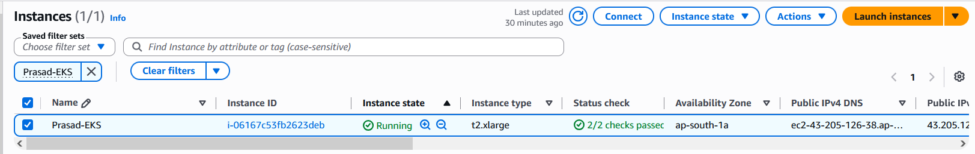

5. Solution Architecture
High-Level Architecture
User Request
|
|
Terraform
|
|
Amazon EKS Cluster
|
--------------------------------
| |
Kubernetes API Managed Node Group
|
--------------------
| |
EC2 Worker 1 EC2 Worker 2
|
Kubernetes Pods
|
NGINX Application
|
AWS LoadBalancer
|
Users

6. Components Used
Component | Purpose
Terraform | Infrastructure automation
Amazon EKS | Managed Kubernetes service
EC2 | Worker nodes
IAM | Access control
VPC | Network isolation
Security Groups | Traffic control
Kubernetes | Container orchestration
LoadBalancer | Application exposure

7. Prerequisites
Software Installed
Verify:
terraform version

aws --version
kubectl version --client

AWS CLI Configuration
Command executed:
aws configure
Validation:
aws sts get-caller-identity

8. Terraform Project Structure
Created directory:
mkdir terraform-eks-poc

cd terraform-eks-poc
Structure:
terraform-eks-poc

├── provider.tf
├── versions.tf
├── variables.tf
├── terraform.tfvars
├── eks.tf
├── outputs.tf

9. Terraform Implementation
provider.tf
provider "aws" {
region = "ap-south-1"
}

variables.tf
variable "region" {
description = "AWS Region"
type = string
}

variable "cluster_name" {
description = "EKS Cluster Name"
type = string
}

variable "cluster_version" {
description = "EKS Version"
type = string
}

variable "vpc_id" {
description = "Existing VPC ID"
type = string
}

variable "public_subnets" {
description = "Existing Public Subnets"
type = list(string)
}

terraform.tfvars
region = "ap-south-1"

cluster_name = "poc-eks"

cluster_version = "1.30"

vpc_id = "vpc-0a15fa78fb8b199f6"

public_subnets = [
"subnet-01ff324c046abd0a6",
"subnet-00d252d42e6758655"
]

10. EKS Module Configuration
eks.tf
Includes:
- Cluster creation
- Node group
- Security rules
- Scaling configuration
module "eks" {

source = "terraform-aws-modules/eks/aws"
version = "~> 20.37"

cluster_name = var.cluster_name
cluster_version = var.cluster_version

vpc_id = var.vpc_id
subnet_ids = var.public_subnets

enable_cluster_creator_admin_permissions = true

cluster_endpoint_public_access = true

cluster_endpoint_private_access = true

cluster_security_group_additional_rules = {

vpc_https_access = {

description = "Allow VPC access to Kubernetes API"

protocol = "tcp"

from_port = 443

to_port = 443

type = "ingress"

cidr_blocks = [
"10.0.0.0/16"
]

}

}

eks_managed_node_groups = {

workers = {

desired_size = 2

min_size = 2

max_size = 5

instance_types = [
"t3.medium"
]

capacity_type = "ON_DEMAND"

}

}

tags = {

Environment = "POC"

Project = "Terraform-EKS"

}

}

11. Terraform Execution Steps
Initialize
Command:
terraform init
Output:
Terraform has been successfully initialized

Validate
Command:
terraform validate
Output:
Success! Configuration is valid

Plan
Command:
terraform plan

Apply
Command:
terraform apply
Confirmation:
yes

12. EKS Cluster Validation
Command:
aws eks describe-cluster \
--name poc-eks \
--region ap-south-1
Expected:
ACTIVE

13. Kubernetes Configuration

Command:
aws eks update-kubeconfig \
--region ap-south-1 \
--name poc-eks

14. Worker Node Validation
Command:
kubectl get nodes
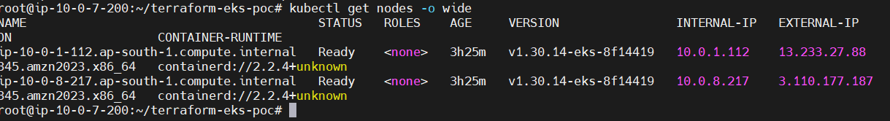

15. Application Deployment
Deployment:
kubectl create deployment nginx \
--image=nginx

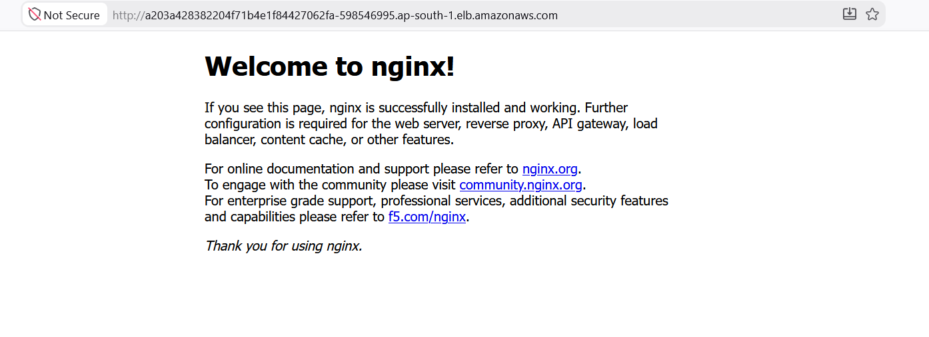
Expose:
kubectl expose deployment nginx \
--type=LoadBalancer \
--port=80

Validation:
kubectl get svc

Application Test:
curl http://<LOADBALANCER_URL>
Output:
Welcome to nginx!

16. Scalability Testing
Scale application:
kubectl scale deployment nginx \
--replicas=5
Verify:
kubectl get pods

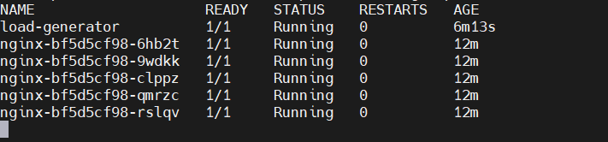

17. Issues Encountered During POC
Issue 1
Terraform duplicate module
Error:
Duplicate module call
Resolution:
Removed duplicate:
rm nodegroup.tf
Issue 2
AWS Authentication Error
Error:
InvalidClientTokenId
Resolution:
Reconfigured AWS credentials.

Issue 3
kubectl timeout
Error:
dial tcp 10.0.1.75:443 timeout
Resolution:
Added:
Security Group inbound rule
TCP 443
Source:
10.0.0.0/16

18. Final Validation Summary
Item | Status
Terraform Deployment | Completed
EKS Cluster | Created
Worker Nodes | Ready
kubectl Access | Working
Application Deployment | Completed
LoadBalancer | Working
Scalability | Tested

19. Results Achieved
✔ Fully automated EKS provisioning
✔ Reduced manual deployment effort
✔ Kubernetes cluster created successfully
✔ Application deployed successfully
✔ External access validated
✔ Scaling capability demonstrated

20. Benefits
Operational Benefits
- Faster environment delivery
- Repeatable deployments
- Reduced human errors
Technical Benefits
- Infrastructure as Code
- Automated scaling
- Cloud-native architecture
************************************

